1.

#include<stdio.h>

void main()

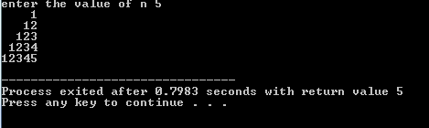{

int i,j,n;

printf("enter the value of n ");

scanf("%d",&n);

for(i=1;i<=n;i++)

{

for(j=i;j<n;j++)

{

printf(" ");

}

for(j=1;j<=i;j++)

{

printf("%d",j);

}

printf("\n");

}

2.

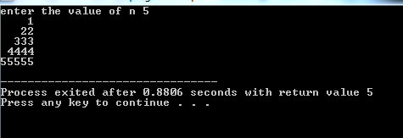#include<stdio.h>

void main()

{

int i,j,n;

printf("enter the value of n ");

scanf("%d",&n);

for(i=1;i<=n;i++)

{

for(j=i;j<n;j++)

{

printf(" ");

}

for(j=1;j<=i;j++)

{

printf("%d",i);

}

printf("\n");

}

}

3.

#include <stdio.h>

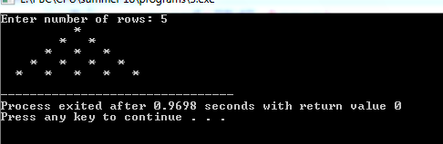int main()

{

int rows, coef = 1, space, i, j;

printf("Enter number of rows: ");

scanf("%d",&rows);

for(i=0; i<rows; i++)

{

for(space=1; space <= rows-i; space++)

printf(" ");

for(j=0; j <= i; j++)

{

printf("\* ");

}

printf("\n");

}

return 0;

}

4.

#include <stdio.h>

int main()

{

int rows, coef = 1, space, i, j;

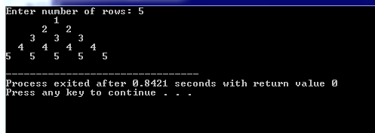 printf("Enter number of rows: ");

scanf("%d",&rows);

for(i=1; i<=rows; i++)

{

for(space=1; space <= rows-i; space++)

{

printf(" ");

}

for(j=1; j <= i; j++)

{

printf("%d ",i);

}

printf("\n");

}

return 0;

}

5.

#include <stdio.h>

int main()

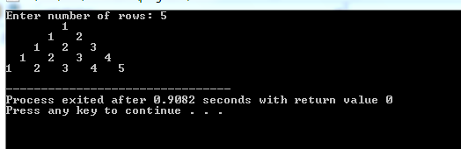{

int rows, coef = 1, space, i, j;

printf("Enter number of rows: ");

scanf("%d",&rows);

for(i=1; i<=rows; i++)

{

for(space=1; space <= rows-i; space++)

{

printf(" ");

}

for(j=1; j <= i; j++)

{

printf("%d ",j);

}

printf("\n");

}

return 0;

}

6.

#include <stdio.h>

int main()

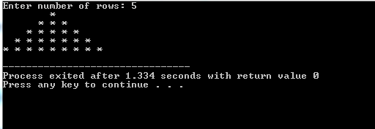{

int i, space, rows, k=0;

printf("Enter number of rows: ");

scanf("%d",&rows);

for(i=1; i<=rows; ++i)

{

for(space=1; space<=rows-i; ++space)

{

printf(" ");

}

for(k=0;k!=2\*i-1;k++)

{

printf("\* ");

}

printf("\n");

}

return 0;

}

7.